**Roll no- MCA139**

**University Registration no- TKM20MCA-2010**

**Git repository link -**

**EXTERNAL LAB EXAM (1ST SEMESTER)**

**WEB PROGRAMMING LAB**

**QUESTION**

Create a web portal for online booking for a convention centre-

a) Owner can enter their convention centre details (name, location, capacity, available date,

contact details)

b) User can book the centre by giving their name, contact details, convention centre name,

occasion date, capacity)

Display available convention centres on that particular date, if the expected convention centre is already booked

**DESIGN**

1. Create a web portal for online booking for a convention centre
2. Enter the details for convention centre such as name, location, capacity, available date, contact details (Online_booking_details.php)
3. For this information user can book for the convention centre by giving their details such as name, contact details, convention centre name, occasion date, capacity(booking.php)
4. Then the page directs towards the confirmation for booking(booking_details.php)
5. Then display the available convention centre on that particular date, if the expected convention centre is already booked.

**PROGRAM CODE**

1. **//dbconnection(1).php**

<?php

//Establishing connection with the database

define('DB_SERVER', 'localhost:3306');

define('DB_USERNAME', 'root');

define('DB_PASSWORD', '');

define('DB_DATABASE', 'convention_centre');

$db = mysqli_connect(DB_SERVER,DB_USERNAME,DB_PASSWORD,DB_DATABASE);

?>

1. **//Online_booking_details.php**

<!DOCTYPE HTML>

<html>

<body bgcolor="pink">

<center><h2>ONLINE BOOKING FOR CONVENTION CENTRE</h2></center>

<center><h3>Booking Details are available here</h3></center>

<form action="booking_details.php" method="post">

<table border="2" align="center" cellpadding="5" cellspacing="5">

<tr>

<td> Enter Name :</td>

<td> <input type="text" name="name" size="48"> </td>

</tr>

<tr>

<td> Enter Location :</td>

<td> <input type="text" name="contact" size="48"> </td>

</tr>

<tr>

<td> Enter Capacity :</td>

<td> <input type="text" name="convention centre name" size="48"> </td>

</tr>

<tr>

<td> Enter Available date :</td>

<td> <input type="text" name="occasion date" size="48"> </td>

</tr>

<tr>

<td> Enter Contact details : </td>

<td> <input type="text" name="capacity" size="48"> </td>

</tr>

<tr>

<td></td>

<td>

<br>

<br>

<input type="Submit" value="Submit">

<input type="reset" value="Reset">

</td>

</tr>

</table>

</form>

</body>

</html>

1. **//booking_details.php**

<!DOCTYPE HTML>

<html>

<body bgcolor="pink">

<center><h2>ONLINE BOOKING CONVENTION CENTRE</h2></center>

<br>

<?php

include("dbconnection(1).php");

$isbn=$_POST["name"];

$title=$_POST["location"];

$author=$_POST["capacity"];

$edition=$_POST["available_dates"];

$publication=$_POST["contact_details"];

$query = "insert into online_booking(name,location,capacity,available_dates,contact_details) values('$name','$location','$capacity','$available_dates','$contact_details')";

$result = mysqli_query($db,$query);

?>

<h3> Successfully Registered the covention centre details </h3>

<a href="booking.php"> To Book for Convention Centres click here </a>

</body>

</html>

1. **//booking.php**

<!DOCTYPE HTML>

<html>

<body bgcolor="pink">

<center><h2>ONLINE BOOKING FOR CONVENTION CENTRE</h2></center>

<form action="booking_successful.php" method="post">

<table border="2" align="center" cellpadding="5" cellspacing="5">

<tr>

<td> Enter name :</td>

<td> <input type="text" name="name" size="48"> </td>

</tr>

<tr>

<td> Enter contact details :</td>

<td> <input type="text" name="contact" size="48"> </td>

</tr>

<tr>

<td> Enter convention centre name :</td>

<td> <input type="text" name="convention centre name" size="48"> </td>

</tr>

<tr>

<td> Enter occasion date :</td>

<td> <input type="text" name="occasion date" size="48"> </td>

</tr>

<tr>

<td> Enter capacity : </td>

<td> <input type="text" name="capacity" size="48"> </td>

</tr>

<tr>

<td></td>

<td>

<input type="Submit" value="Submit">

<input type="reset" value="Reset">

</td>

</tr>

</table>

</form>

</body>

</html>

1. **//booking_successful.php**

<!DOCTYPE HTML>

<html>

<title>Successful.php</title>

<body>

<div style="text-align:left"><h1>Booked Successful </h1></div>

<br/>

<a href="Display_Booking.php">Click to Display the available centres details</a>

</body>

</html>

1. **//Display_Booking.php**

<!DOCTYPE HTML>

<html>

<body bgcolor="pink">

<center><h2>ONLINE BOOKING FOR CONVENTION CENTRE</h2></center>

<br>

<?php

include("dbconnection(1).php");

$query = "select name,location,capacity,available_dates,contact_details from online_booking";

$result = mysqli_query($db,$query);

if(capacity>0)

{

?>

<table border="2" align="center" cellpadding="5" cellspacing="5">

<tr>

<th> NAME </th>

<th> LOCATION </th>

<th> CAPACITY </th>

<th> AVIALABLE DATES </th>

<th> CONTACT DETAILS </th>

</tr>

<?php while($row = mysqli_fetch_assoc($result))

{

?>

<tr>

<td><?php echo $row["name"];?> </td>

<td><?php echo $row["location"];?> </td>

<td><?php echo $row["capacity"];?> </td>

<td><?php echo $row["available_dates"];?> </td>

<td><?php echo $row["contact_details"];?> </td>

</tr>

<?php

}

}

else

echo "<center>No booking is available for this convention centre </center>" ;

?>

</table>

</body>

</html>

<br>

**OUTPUT**

**//Table creation**

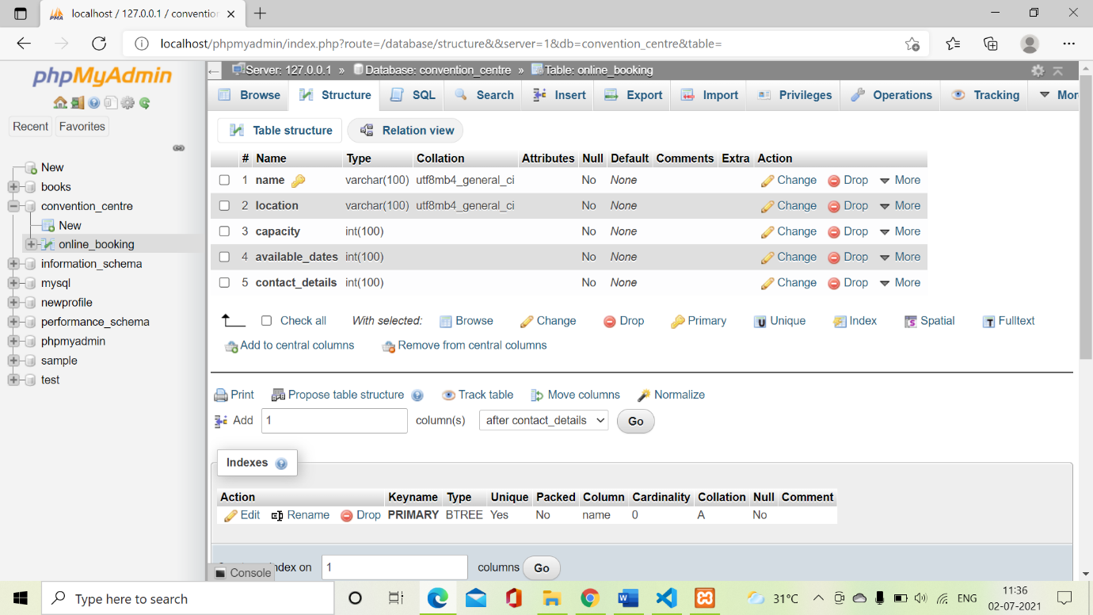

**//Dbconnection**

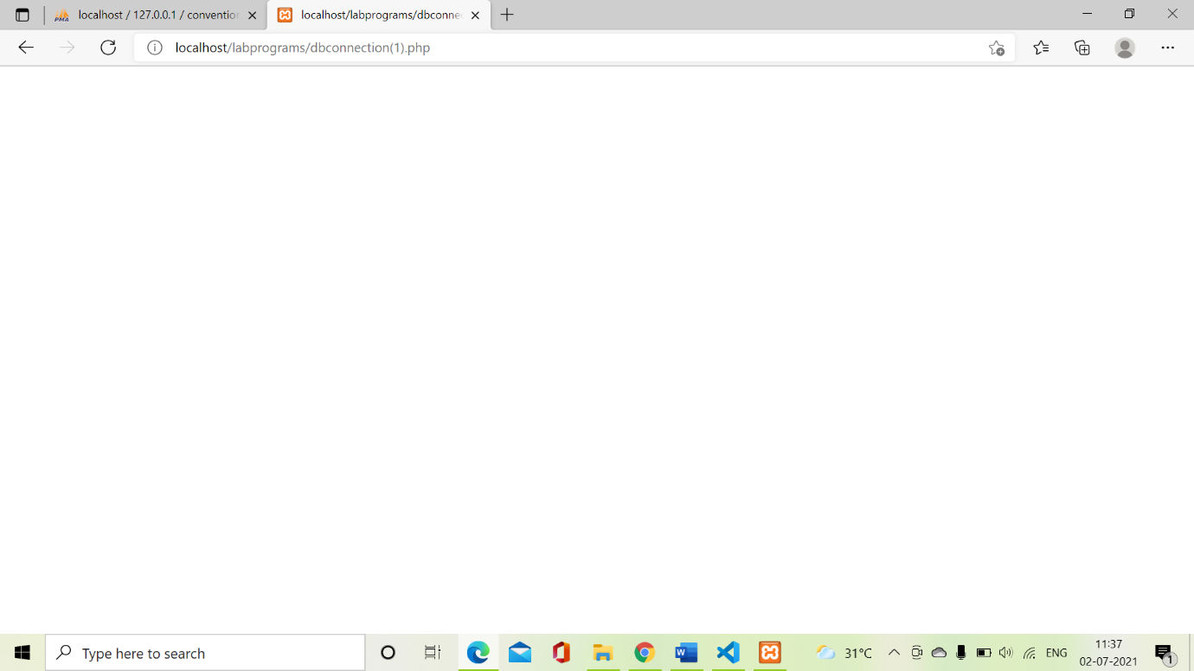

**Online_booking_details.php**

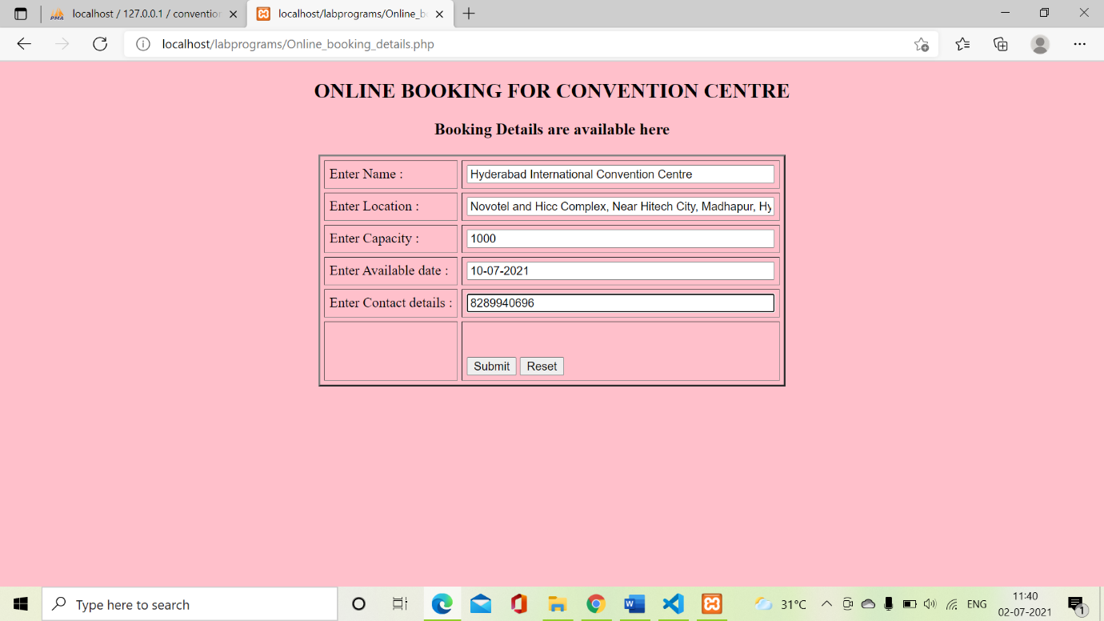

**//booking_details.php**

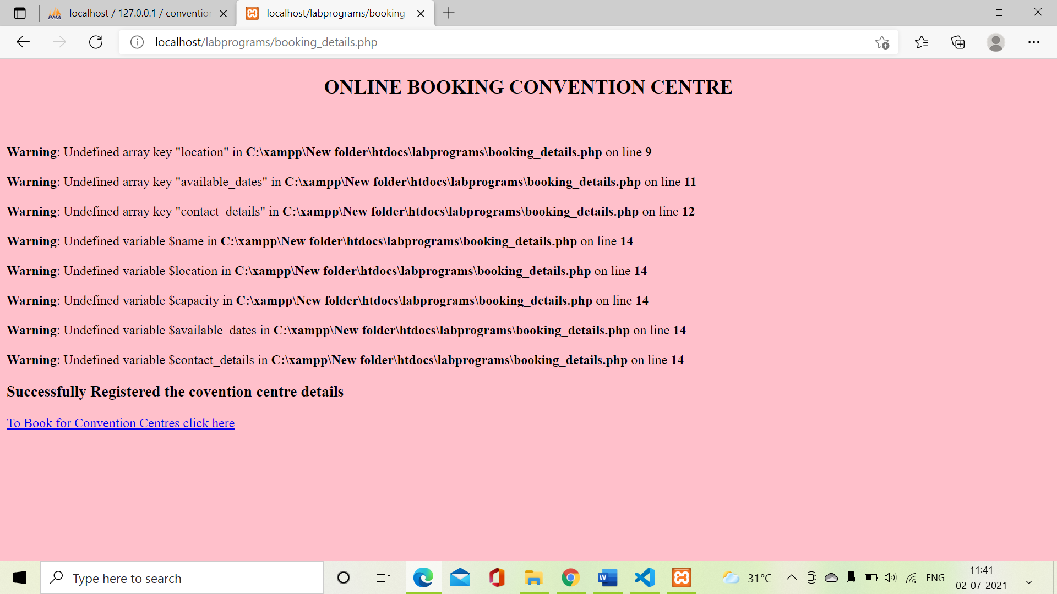

**//booking.php**

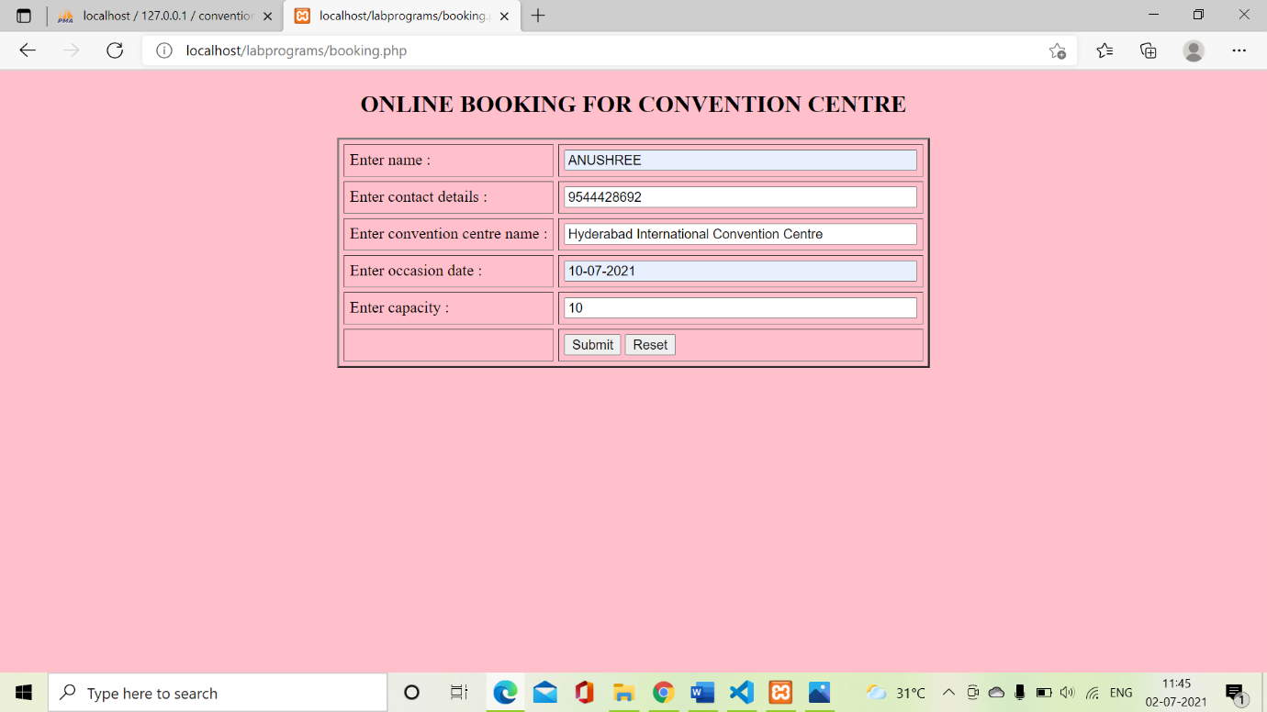

**//booking_successful.php**

